**STOCK PRECISION PRO**

**Capstone Project Report**

**MID SEMESTER EVALUATION**

**Submitted by:**

**(102166001) Ajayveer Singh Dhillon**

**(102116025) Arshdeep Singh**

**(102296003) Deepanshu Thakur**

**(102116101) Madhusudan**

**(102116056) Sukhmandeep Singh**

**BE Fourth Year, CoSE**

**CPG No: 15**

Under the Mentorship of

Dr. Ravinder Kumar

Associate Professor

Dr. Jatin Bedi

Assistant Professor



**Computer Science and Engineering Department**

**Thapar Institute of Engineering and Technology, Patiala**

**August 202****4**

**ABSTRACT**



The Stock Recommender System is a cutting-edge tool created to help investors choose the most appropriate stocks by conducting a thorough analysis of financial ratios, industry-specific data, and real-time market indicators. This project utilises daily data from the Yahoo Finance API and other financial data sources to offer a current and varied list of stock recommendations. Utilising cutting-edge machine learning techniques like time series analysis, Convolutional Neural Networks (CNN) etc., our system strives to enhance the accuracy of predicting future stock performance. In addition, the project utilises web scraping techniques to analyse the most recent news headlines, providing a more informed investment strategy. The system's front end will be designed as a website that is intuitive and accessible, allowing users to easily utilise all of its features. This report provides a comprehensive overview of the project's architecture, methodology, and anticipated results.llllllllllllllllllllllllllllllllllllllllllllllllllllllllllllllllllllllllllllllllll

**DECLARATION**



We hereby declare that the design principles and working prototype model of the project entitled Stock precision pro is an authentic record of our own work carried out in the Computer Science and Engineering Department, TIET, Patiala, under the guidance of Dr. Ravinder Kumar and Dr. Jatin Bedi during 7th semester (2024).

Date:

| **Roll No.** | **Name** | **Signature** |
| --- | --- | --- |
| 102166001 | Ajayveer Singh Dhillon |  |
| 102116025 | Arshdeep Singh |  |
| 102296003 | Deepanshu Thakur |  |
| 102116101 | Madhusudan |  |
| 102116056 | Sukhmandeep Singh |  |

*Counter Signed By:*

Faculty Mentor: Co-Mentor ( if any):

Dr. Ravinder Kumar Dr. Jatin Bedi

Associate Professor Assistant Professor

CSED, CSED,

TIET, Patiala TIET, Patiala

**ACKNOWLEDGEMENT**



We would like to express our thanks to our mentors Dr. Ravinder Kumar and Dr. Jatin Bedi. He has been of great help in our venture and an indispensable resource of technical knowledge. He is truly an amazing mentor to have.

We are also thankful to Dr. Shalini Batra, Head, Computer Science and Engineering Department, the entire faculty and staff of the Computer Science and Engineering Department, and also our friends who devoted their valuable time and helped us in all possible ways towards successful completion of this project. We thank all those who have contributed either directly or indirectly towards this project.

Lastly, we would also like to thank our families for their unyielding love and encouragement.

They always wanted the best for us and we admire their determination and sacrifice.

| **Roll No.** | **Name** | **Signature** |
| --- | --- | --- |
| 102166001 | Ajayveer Singh Dhillon |  |
| 102116025 | Arshdeep Singh |  |
| 102296003 | Deepanshu Thakur |  |
| 102116101 | Madhusudan |  |
| 102116056 | Sukhmandeep Singh |  |

Date:

**TABLE OF CONTENTS**



**ABSTRACT 1**

**DECLARATION 2**

**ACKNOWLEDGEMENT 3**

**LIST OF TABLES 4**

**LIST OF FIGURES 5**

**LIST OF ABBREVIATIONS 6**

**CHAPTER**

| **1.** | **Introduction** | |  |
| --- | --- | --- | --- |
|  | 1.1 | Project Overview **7** |  |
|  | 1.2 | Need Analysis 9 |  |
|  | 1.3 | Research Gaps 10 |  |
|  | 1.4 | Problem Definition and Scope 12 |  |
|  | 1.5 | Assumptions and Constraints 13 |  |
|  | 1.6 | Standards 14 |  |
|  | 1.7 | Approved Objectives 15 |  |
|  | 1.8 | Methodology 16 |  |
|  | 1.9 | Project Outcomes and Deliverables 17 |  |

1.10 Novelty of Work 18

1. **Requirement Analysis** 2.1 Literature Survey

2.1.1 Theory Associated With Problem Area 19

2.1.2 Existing Systems and Solutions 19

2.1.3 Research Findings for Existing Literature 20

2.1.4 Problem Identified 25

2.1.5 Survey of Tools and Technologies Used 26

2.2 Software Requirement Specification 26

2.2.1 Introduction 26

2.2.1.1 Purpose 26

2.2.1.2 Intended Audience and Reading Suggestions 26

2.2.1.3 Project Scope 26

2.2.2 Overall Description 27

2.2.2.1 Product Perspective 27

2.2.2.2 Product Features 27

2.2.3 External Interface Requirements 27

2.2.3.1 User Interfaces 27

2.2.3.2 Hardware Interfaces 28

2.2.3.3 Software Interfaces 28

2.2.4 Other Non-functional Requirements 28

2.2.4.1 Performance Requirements 29

2.2.4.2 Safety Requirements 28

2.2.4.3 Security Requirements 28

2.3 Cost Analysis 29

2.4 Risk Analysis 29

* 1. **Methodology Adopted**

3.1 Investigative Techniques 30

3.2 Proposed Solution 32

3.3 Work Breakdown Structure 34

3.4 Tools and Technology 35

1. **Design Specifications**

4.1 System Architecture 36

4.2 Design Level Diagrams 38

4.3 User Interface Diagrams 42

4.4 Snapshots of Working Prototype 48

1. **Conclusions and Future Scope**

5.1 Work Accomplished 56

5.2 Conclusions 57

5.3 Environmental Benefits 58

5.4 Future Work Plan 59

**APPENDIX A: References**

**APPENDIX B: Plagiarism Report**

**LIST OF TABLES**



| Table No. | Caption | Page No. |
| --- | --- | --- |
| 1 | Need Analysis | 9 |
| 2 | Assumptions & Constraints | 13 |
| 3 | Research Findings | 20 |

**LIST OF FIGURES**



| Figure no. | Caption | Page No. |
| --- | --- | --- |
| 1 | Workplan | 33 |
| 2 | Mvc architecture | 36 |
| 3 | Tier architecture | 38 |
| 4 | Swimlane diagram | 39 |
| 5 | Activity diagram | 40 |
| 6 | Dfd level 0 | 43 |
| 7 | Dfd level1 | 44 |
| 8 | Dfd level 2 | 45 |
| 9 | Use case | 47 |

**LIST OF ABBREVIATIONS**



| ABBR1 | P/E | Price to Earning Ratio |
| --- | --- | --- |
| ABBR2 | ROE | Return on Equity |
| ABBR3 | D/E | Debt to Equity |
| ABBR4 | API | Application programming interface |
| ABBR5 | CNN | Convolutional Neural Networks |
| ABBR6 | LSTM | Long short-term memory |
| ABBR7 | SRS | Software Requirement Specifications |
| ABBR8 | UI | User Interface |
| ABBR9 | UX | User Experience |
| ABBR10 | MVC | Model-View-Controller |
| ABBR11 | PK | Primary Key |

**INTRODUCTION**



**1.1 Project Overview**

The Stock Recommender System is an integrated system designed to assist individuals in making informed decisions in the stock market. In today's ever-changing financial landscape, making informed decisions about stocks goes beyond relying on gut feelings. It calls for a methodical strategy that integrates data-driven analysis and up-to-the-minute observations. This project utilises sophisticated machine learning techniques, financial modelling, and sentiment analysis to offer users daily updated stock recommendations.………………………………………………...  
  
The system seamlessly combines data from various sources, including the Yahoo Finance API for financial ratios and historical data, as well as web scraping tools for extracting news headlines. Through the utilisation of different machine learning models like Convolutional Neural Networks (CNN), K-Supervised Nearest Neighbours (KNN), and time series models, the system is capable of assessing stocks based on their industry, performance indicators, and market sentiment.  
  
The main goal of the Stock Recommender System is to improve the decision-making process for investors by offering precise, timely, and diverse stock recommendations. The system is designed to:  
  
**Examine Financial Ratios and Indicators**: Through an analysis of important financial ratios like the P/E ratio, ROE, and D/E ratio, the system assesses the financial well-being of companies and their potential for growth.aaaaaaaaaaaaaaaaaaaaaaaaaaaaaaaaaaaaaaaaaaaaaaaaaaaaaaaaaaaaaaaaa  
  
**Utilise Market Sentiment**: The system incorporates sentiment analysis from news headlines and social media platforms to assess the market's perception of a stock, which can have a significant influence on its performance.………………………………………………………………………  
  
Provide targeted suggestions for improvement in a specific field. The system organises stocks by industry, enabling more focused and pertinent recommendations. This assists investors in diversifying their portfolios by concentrating on sectors that are in line with their investment strategies.  
  
Utilise Machine Learning for Prediction: By incorporating machine learning models, the system can make accurate predictions about stock trends and offer recommendations. These predictions are not solely based on historical data, but also take into account intricate patterns found in financial and sentiment data.

The architecture of our Stock Recommender System is carefully crafted to guarantee scalability, reliability, and efficiency. The system is made up of several important components:  
  
**Data Ingestion Layer**: This layer is in charge of gathering data from various sources such as the Yahoo Finance API, financial news websites, and social media platforms. Data is fetched on a daily basis to ensure that the system stays current with the most recent market conditions.  
  
**Data Processing and Preprocessing**: The processing of raw data involves extracting relevant features such as financial ratios, sentiment scores, and technical indicators. This stage requires the data to be cleaned, normalised, and transformed in order to prepare it for model input.  
  
**Machine Learning Models**: The heart of the system consists of a variety of machine learning models. Time series models are commonly employed for predicting stock prices, while CNNs are utilised to examine patterns in financial data. KNN is used to cluster and classify stocks based on their similarities.aaaaaaaaaaaaaaaaaaaaaaaaaaaaaaaaaaaaaaaaaaaaaaaaaaaaaaaaaaaaaaaaaaaaaaaaa  
  
**Recommendation Engine**: The processed data and model outputs are inputted into the recommendation engine, which produces a list of suggested stocks. This engine considers the user's preferences, including their risk tolerance and industry focus, in order to customise the recommendations.  
  
**User Interface**: The system's front end is a web-based interface that allows users to easily view recommended stocks, access in-depth analysis, and personalise their settings. The interface is designed to be user-friendly, ensuring that users can easily access the information necessary for making informed decisions.aaaaaaaaaaaaaaaaaaaaaaaaaaaaaaaaaaaaaaaaaaaaaaaaaaaaaaaaaaaaaaa  
  
A valuable tool for expanding one's horizons: Found on the homepage, this feature assists users in organising and refining stocks according to industries and financial metrics.aaaaaaaaaaaaaaaaaaaa

Up-to-date Data Updates: The system ensures that users have access to the most current market conditions and trends by updating its recommendations daily.aaaaaaaaaaaaaaaaaaaaaaaaaaaaaaaaa  
  
Comprehensive Stock Analysis: Our system offers a thorough examination of every recommended stock, encompassing historical performance, financial ratios, and sentiment scores.aaaaaaaaaaaaaa  
  
Customisation Options: Users have the ability to personalise their experience by adjusting preferences like risk level, industry focus, and alert notifications for specific stocks or market conditions.  
In conclusion the Stock Recommender System is a cutting-edge tool that caters to investors of all levels of experience. Through the integration of financial analysis, machine learning, and real-time data processing, the system provides a holistic solution to the obstacles faced in stock market investing. The project not only aims to provide accurate stock recommendations but also to improve the user experience by making complex financial data accessible and actionable.  
  
With the system's ongoing evolution, a new standard in stock market recommendation platforms is being set. Users can gain a competitive edge in navigating the financial markets.

**1.2 Need Analysis**

| 1. Survey Driven Demand | Insight: Our team conducted a pre-project survey and discovered a strong interest in a stock recommender tool among potential users.  Findings: The survey revealed that a significant portion of respondents expressed interest in a stock recommendation system, regardless of their current level of knowledge about stocks. This emphasises a market gap and a sincere interest among users to possess a tool that streamlines stock investment decisions. | Significance: The survey-driven approach guarantees that our project is in line with the real needs and preferences of the target audience, which enhances the chances of user adoption and satisfaction with the proposed stock recommender system. |
| --- | --- | --- |
| 1. Industry-Centric Sorting: | Challenge: Stock recommendations that are not tailored to users' specific industry interests and expertise can be irrelevant and unhelpful, as they do not suggest specific stocks. This process can be quite tedious and time-consuming for individuals. | Solution: The system utilises industry-centric sorting to provide users with personalised recommendations that align with their industry focus. It surpasses simple evaluation by providing recommendations on individual stocks, saving users from the tedious process of manually sifting through extensive data and improving their capacity to make well-informed investment choices. |
| 1. Investment Decision Support | Challenge: Individuals who are new to investing or even those with more experience may require assistance in making informed investment decisions. | Solution: The solution provided is a recommender system that functions as a decision support tool. It utilises machine learning models to provide users with insights and evaluations, enabling them to make data-driven decisions. |
| 1. Real-Time Updates | Challenge: One challenge that many investors face is the need for support in making well-informed investment decisions, whether they are novice or experienced. | Solution: The recommender system serves as a valuable tool, providing users with valuable insights and evaluations generated by machine learning models. This enables users to make informed decisions based on data-driven analysis. |

Table No.-1

**1.3 Research Gaps**

1. Incorporating Alternative Data Sourcesaaaaaaaaaaaaaaaaaaaaaaaaaaaaaaaaaaaaaaaaaaaaaaaaaaa  
Lack of research: Conventional financial indicators have been widely utilised, but there is a lack of research on incorporating non-traditional data sources like satellite imagery, consumer foot traffic, and environmental factors into stock recommendation systems. These sources have the potential to offer valuable perspectives on market conditions and company performance, but they are not being fully utilised.aaaaaaaaaaaaaaaaaaaaaaaaaaaaaaaaaaaaaaaaaaaaaaaaaaaaaaaaaaaaaaaa  
Reference:  
  
Zhang, Y., Li, Y., & Jiang, Y. (2023). Exploring Alternative Data in Stock Market Prediction: A Thorough Examination. ACM Computing Surveys, 56(3), 1-35. This paper explores the recent developments in utilising alternative data sources for predicting stock market trends, highlighting the opportunities and obstacles in incorporating them into recommender systems.

2. Lack of research on the explainability of machine learning models Although deep learning models such as CNNs and LSTMs are gaining popularity in stock prediction, there remains a notable lack of transparency in how these models work. Investors have a preference for models that offer transparency in the decision-making process. However, the limited usability of many machine learning models in financial decision-making is due to their "black box" nature.  
Reference:  
  
Molnar, C. (2022). Interpretable Machine Learning: A Guide for Enhancing the Explainability of Complex Models. Springer. This book offers a thorough examination of techniques for elucidating machine learning models and delves into the unique obstacles and requirements in financial contexts.

3. Research Gap in Dynamic Portfolio Optimisation: There is a limited amount of research available on dynamic portfolio optimisation within stock recommendation systems. Many existing systems primarily concentrate on portfolios that remain unchanged or only slightly change over time. However, there is a demand for algorithms that can dynamically adapt portfolios in response to real-time data, changing market conditions, and user preferences. These algorithms should also consider transaction costs and other practical limitations.aaaaaaaaaaaaaaaaaaaaaaaaaaaaaaaaaaaaa  
Reference:  
  
Liu, Y., Zhang, S., & Wang, J. (2023). Dynamic Portfolio Optimisation in Financial Markets: Advances and Challenges. Journal of Financial Engineering, 10(1), 2050010. This paper examines recent developments in dynamic portfolio optimisation and emphasises the need for additional research, specifically in relation to stock recommendation systems.

4. Research Gap in Real-Time Sentiment Analysis Using Social Media: Although sentiment analysis is widely used, there is still a lack of progress in analysing social media data in real-time, particularly from platforms like Twitter. Handling substantial amounts of data in real-time and accurately assessing market sentiment, particularly considering the chaotic and frequently conflicting nature of social media content, remains a persistent challenge.  
Reference:  
  
Xing, F., Cambria, E., & Welsch, R. E. (2023). Real-Time Twitter Sentiment Analysis for Stock Market Prediction. The article "IEEE Transactions on Affective Computing, Early Access, 1-14" provides valuable insights into the field of affective computing. This paper discusses the most recent techniques for conducting real-time sentiment analysis using social media data. It highlights the difficulties involved and explores the various ways in which these methods can be applied, particularly in stock recommendation systems.

5. Analysis of different markets and the impact of globalisation  
Research Gap: Many stock recommendation systems are tailored to specific markets, with a primary focus on major U.S. stock exchanges. Nevertheless, there is an increasing demand for systems capable of analysing and providing stock recommendations across various global markets. It is necessary to have models that take into consideration various economic conditions, regulatory environments, and market dynamics on a global scale.  
Reference:  
  
Shen, W., & Zheng, L. (2022). Exploring Cross-Market Stock Recommendation Systems: Overcoming Challenges and Embracing Opportunities. Journal of Global Financial Markets, 13(2), 105-125. This article explores the growing importance of cross-market analysis in stock recommendation systems and highlights the significant challenges and opportunities for future research in this area.

**1.4 Problem Definition with scope**

The main difficulty in stock market analysis is the requirement to handle and understand substantial amounts of information from various sources in real-time. This project aims to create a stock recommender system that tackles this challenge by:a

aaaaaaaaaaaaaaaaaaaaaaaaaaaaaaaaaaa

* Gathering daily stock data from various sources, including Yahoo Finance API.  
  Examining this data utilising financial ratios like P/E ratio, P/B ratio, and ROE, among others.
* Utilising machine learning models such as time series forecasting, CNN, and KNN to make predictions about stock performance.aaaaaaaaaaaaaaaaaaaaaaaaaaaaaaaaaaaaaa
* Integrating up-to-the-minute news headlines into the analysis to offer context and improve the precision of recommendations.aaaaaaaaaaaaaaaaaaaaaaaaaaaaaaaaaaaaaaaaaaaaaaaaaa
* Creating an intuitive web interface that enables users to effortlessly access the recommendations.

**1.5 Assumptions & Constraints**

| **S.no** | **Category** | **Assumption/Constraint** | **Explanation** |
| --- | --- | --- | --- |
| 1 | **Assumption** | **Accurate and Timely Data** | The system assumes that the data fetched from the Yahoo Finance API and other data sources are accurate and updated in real-time. |
| 2 | **Assumption** | **User Financial Literacy** | It is assumed that users of the system have a basic understanding of financial markets and are familiar with common investment concepts and stock market terms. |
| 3 | **Constraint** | **Real-Time Data Processing** | The system is constrained by the need to process large volumes of data in real time, which requires substantial computational resources and efficient algorithms. |
| 4 | **Constraint** | **Scalability and Performance** | The system must be scalable to accommodate a growing number of users and data requests without degrading performance, necessitating robust infrastructure. |
| 5 | **Constraint** | **Compliance with Financial Regulations** | The system must comply with international financial regulations and data protection laws, which can limit the scope of data usage. |

Table No.-2

**1.6 Standards**

In order to guarantee quality, reliability, and conformance in all phases of development and operation, the Stock Recommender System conforms to strict guidelines and best practices.  
  
Integrity and Data Management Data veracity: Guarantees the reliability and veracity of data by implementing rigorous validation procedures.

Data Protection: Maintains transparency in the use of data and the decision-making process of algorithms.

Accessibility and User Interface: Complies with the WCAG standards to guarantee that all users can access the content.

Responsive Design: Guarantees a consistent and efficient user experience on a variety of platforms and devices.

Reliability and Performance System Availability: Implements disaster recovery strategies and is designed for high availability.

Performance Optimisation: Continuously optimises performance to effectively manage peak loads through load testing.

**1.7 Objectives**

**Algorithm Development**: Develop and refine algorithms for sorting stocks based on industry-specific criteria, ensuring the system's capability to provide targeted recommendations in a dynamic market environment.

**Real-time Data Integration**: Establish a robust system for daily data updates from various sources, including Yahoo Finance library, stock symbol API, and other databases. Ensure seamless integration to keep the sorted stock lists current and reflective of changing market dynamics.

**Parameter Optimization**: Focus on optimizing the selection and utilization of financial ratios and indicators for dynamic stock evaluation. This objective aims to enhance the effectiveness of the parameters used in assessing the health and performance of companies within their respective industries.

**User Experience Enhancement**: Evaluate and enhance the user-friendly interface of the website, making it accessible for both seasoned investors and beginners. This objective ensures an intuitive and engaging interaction with the stock recommendation system, fostering a positive user experience.

**1.8 Methodology**

**Algorithm Development**: Data Collection: Gather historical and real-time stock data from Yahoo Finance library, stock symbol API, and relevant databases. Industry-Specific Criteria: Identify and define industry-specific criteria for sorting stocks, considering relevant financial parameters.

Algorithm Design: Develop an algorithm to sort stocks based on the established criteria, ensuring adaptability to dynamic market changes.

**Real-time Data Integration**: Data Source Integration: Establish connections and protocols to seamlessly integrate daily data updates from various sources.

Automation: Implement automated processes to fetch, process, and update the sorted stock lists daily, ensuring real-time relevance.

**Parameter Optimization**: Financial Parameter Selection: Review and select key financial ratios and indicators based on their significance in evaluating stock performance. Dynamic Evaluation Model: Implement a dynamic model for evaluating stocks using the chosen parameters, allowing for continuous optimization.

**User Experience Enhancement**: Interface Evaluation: Conduct user interface evaluations to identify areas for improvement in terms of accessibility and user-friendliness. Feedback Incorporation: Gather user feedback and incorporate necessary changes to enhance the overall user experience. Testing: Conduct thorough testing of the website interface to ensure ease of navigation and interaction.

* 1. **Project Outcomes and Deliverables**

**Stock recommender**: Deliver a fully operational Stock Recommender System that makes real-time, accurate stock suggestions by means of data from several sources. This method seeks to be a vital instrument for investors in order to make wise judgements.aaaaaaaaaaaaaaaaaaaaaa

Key feartures:aaaaaaaaaaaaaaaaaaaaaaaaaaaaaaaaaaaaaaaaaaaaaaaaaaaaaaaaaaaaaaaaaaaaaa

Combining sentiment analysis and financial API data integration helps to:  
Real-time recommendations provide quick stock selections grounded in the most recent information.  
User customising lets one match risk profiles and personal preferences.

**Machine learning**: Models for stock prediction using time series analysis and neural networks among other machine learning models, apply a set of ideas meant to efficiently predict stock market patterns and suggest stocks.

Key feartures:aaaaaaaaaaaaaaaaaaaaaaaaaaaaaaaaaaaaaaaaaaaaaaaaaaaaaaaaaaaaaaaaaaaaaaaaaaaaa  
With constant model training and validation, predictive accuracy guarantees strong accuracy in forecasts.  
Models that can adjust to fresh data will over time improve their forecasting capacity.

**Interface**: Online Based Interface provide a user-friendly interface that enables all user regardless of their investing experience to easily access stock recommendations and manage their investment decisions.  
Key feartures:aaaaaaaaaaaaaaaaaaaaaaaaaaaaaaaaaaaaaaaaaaaaaaaaaaaaaaaaaaaaaaaaaaaaaaaaaaaaa

Simplicity and easy interface design define this.aaaaaaaaaaaaaaaaaaaaaaaaaaaaaaaaaaaaaaaaaaaa  
Interactive tools provide customised alerts and thorough stock analysis capability.

**Documentation**:Training and Documentation Resources create thorough user manuals and documentation outlining how to maximise system features and operate it.aaaaaaaaaaaaaaaaaaaaaaaa  
Key feartures:aaaaaaaaaaaaaaaaaaaaaaaaaaaaaaaaaaaaaaaaaaaaaaaaaaaaaaaaaaaaaaaaaaaaaaaaaaaaa  
Detailed guides for end users detailed technical materials for system maintenance and possible future improvements constitute technical documentation.

* 1. **Novelty of Work**

Our stock recommender system guarantees a complete and current dataset for study by sourcing data from many platforms, including the Yahoo Finance library, stock symbol API, and other trustworthy databases.aaaaaaaaaaaaaaaaaaaaaaaaaaaaaaaaaaaaaaaaaaaaaaaaaaaaaaaaaaaaaaaaaaaaa

**Industry-Centric Sorting**: We use a different method than conventional systems—that of grouping stocks according to their particular industries. This industry-centric sorting makes a more focused and perceptive research possible.aaaaaaaaaaaaaaaaaaaaaaaaaaaaaaaaaaaaaaaaaaaaaaaaaaaa

**Dynamic Parameter Evaluation**: We dynamically assess stocks using widely used financial ratios and indicators. Evaluating the performance and condition of businesses in their particular sectors depends critically on these criteria. aaaaaaaaaaaaaaaaaaaaaaaaaaaaaaaaaaaaaaaaaaaaaaaaaaaaaaaaaa

**Daily Updates**: The technology guarantees that the sorted stock lists for every industry stay current with daily updates. Users can remain updated on shifting market dynamics by means of this real-time information.aaaaaaaaaaaaaaaaaaaaaaaaaaaaaaaaaaaaaaaaaaaaaaaaaaaaaaaaaaaaaaaaaaaaaaaaaa

**Integrated Machine Learning Models**: Our method uses cutting-edge machine learning models like time series analysis, CNN, and KNN, thereby offering sophisticated evaluations of stock performance and hence improving accuracy.aaaaaaaaaaaaaaaaaaaaaaaaaaaaaaaaaaaaaaaaaaaaaaaa

**User-Friendly Interface**: Designed as a user-friendly interface, the interface guarantees accessibility for novice investors as well as seasoned ones. The simple interface helps one to navigate and engage with the stock recommendation system.

**REQUIREMENT ANALYSIS**



**2.1 Literature Survey**

**2.1.1 Theory Associated With Problem Area**

Various methodologies, such as time series analysis, economic indicators, and machine learning techniques like (LSTM) networks and (CNN), are included in the theory that underpins stock market prediction. These techniques are intended to detect patterns and trends in historical stock data, thereby facilitating the precise prediction of future stock prices. By assessing market trends and economic health, the integration of economic indicators into predictive models provides supplementary insights, thereby enhancing the predictive capabilities of these models.

**2.1.2 Existing Systems and Solutions**

A variety of technologies and instruments are employed by current stock market prediction systems. For example, Yahoo Finance data and time series analysis are frequently implemented to forecast stock prices across various investment horizons. In order to enhance the accuracy of predictions, advanced models such as Feature Fusion that employ LSTM-CNN combine temporal and visual data from stock charts. Hybrid models that incorporate deep CNN and reinforcement learning with LSTM, as well as big data processing frameworks, have demonstrated superiority in predicting market trends, particularly in volatility. Additionally, the accuracy of stock recommendation systems is improved by the integration of qualitative data from news and social media when sentiment analysis is combined with feature engineering.

**2.1.3 Research Findings for Existing Literature**

| S No. | Roll Number | Name | Paper Title | Tools/  Technology | Findings | Conclusion |
| --- | --- | --- | --- | --- | --- | --- |
| 1 | 102166001 | Ajayveer Singh Dhillon | Forecasting Using data from Yahoo Finance and analyzing trends. | Yahoo Finance Data    Time Series Analysis | Effectiveness of Time Series Models  Short-Term and Long-Term Forecasts: The results indicate that the forecasting models are equally effective for both short-term and long-term stock price predictions, indicating that these methods are adaptable to a variety of investment horizons.    Safe Investment Range: The study posits that investors can make more informed decisions by identifying a range of stock prices through these combined models, thereby reducing the risk of incurring losses. | The method improves the precision of stock price predictions and provides a practicable solution for investors who wish to reduce risk while navigating the stock market. |
| 2 | 102116026 | Arshdeep Singh | Economic Indicators: tools for analyzing market trends and predicting future  Performance | Economic Indicators  Empirical Analysis  Theoretical Frameworks | Economic Indicators as Predictive Tools: The analysis highlights the importance of economic indicators in predicting future economic performance and comprehending market trends. They assist stakeholders in the identification of patterns, the assessment of risks, and the identification of both strengths and vulnerabilities in the economy.   Strategic Decision-Making: By analysing these indicators, businesses, investors, and policymakers are more capable of making well-informed decisions. These decisions are crucial for the identification of opportunities and the management of risks, as well as the development of proactive strategies for economic stability and growth. | The study underscores the critical role that economic indicators play in influencing strategic decision-making across a variety of sectors. In this way, the importance of economic indicators is emphasised. These indicators are indispensable for the forecasting of market trends and the assessment of economic health, making them invaluable tools for both short-term and long-term planning.    Empowerment through Understanding: Stakeholders acquire the foresight required to effectively navigate dynamic market environments by comprehending and analysing economic indicators. This comprehension enables the development of strategies that improve economic resilience and performance, as well as the identification of trends and improved risk management. |
| 3 | 102296003 | Deepanshu Thakur | **Forecasting stock prices with a feature fusion** | Feature Fusion Technique  Stock Chart Images (Candlestick Charts) | In the prediction of stock prices, the feature fusion LSTM-CNN model outperforms individual models (e.g., LSTM or CNN alone).    The prediction as a result of the combination of temporal features from stock time series and image features from stock chart images.  The candlestick chart is the most effective method for forecasting stock prices among a variety of stock chart images. | The research demonstrates that the utilisation of a combination of temporal and image features It is more precise to determine stock prices when these features are combined from the same stock data than when they are used separately.   By utilising both visual data and time series data, the proposed feature fusion LSTM-CNN model effectively improves prediction performance, providing a promising approach to financial forecasting. |
| 4 | 102116101 | Madhusudan | Big data-based stock trend prediction using deep CNN with reinforcement-LSTM model | Deep CNN  Reinforcement Learning  LSTM (Long Short-Term Memory)  Big Data Processing Framework | The traditional stock prediction models are outperformed by the integrated CNN with LSTM model, which is enhanced by reinforcement learning.  This combination enhances the model's ability to predict stock market trends by capturing the short-term and long-term dependencies in stock data.   The prediction accuracy of the model was considerably enhanced in comparison to other models, particularly in volatile market conditions. | The stock market trends are accurately predicted by the hybrid model, which integrates reinforcement learning, LSTM, and CNN.   The method enables investors to make more precise stock trend predictions, thereby enhancing their decision-making capabilities.   The research illustrates that the accuracy of stock market predictions in a big data environment can be substantially improved by the combination of reinforcement learning and deep learning techniques. |
| 5 | 102116056 | Sukhmandeep  Singh |  | Feature Engineering  Sentiment Analysis | Enhanced Accuracy: Hybrid models, which incorporate machine learning and traditional models, consistently outperform standalone models, resulting in increased accuracy in stock price prediction and trading signals.   Sentiment and Alternative Data: The predictive capabilities of recommendation systems are significantly improved when qualitative sentiment data from news and social media is integrated with quantitative models.   Sector-Specific Models: Sector-specific modelling enhances precision by enabling more domain-specific benchmarking against industry peers, resulting in more customised investment recommendations. | A cross-disciplinary approach is necessary to create robust stock recommendation systems, which involves the integration of financial theory, advanced data science techniques, and machine learning models. The predictive performance is considerably improved by the integration of hybrid models, qualitative sentiment analysis, and quantitative time series models. The research emphasises the necessity of rigorous feature engineering, model validation, and the incorporation of sector-specific strategies to generate actionable insights that can assist retail investors in optimising their portfolios and mitigating risk. |

Table No.-3

**2.1.4 Problem Identified**

In spite of the progress made in predictive modelling, there are still obstacles to attaining consistently high accuracy in a variety of market conditions. Traditional models frequently encounter difficulties in volatile markets, necessitating the development of more resilient systems that can incorporate a variety of data sources, such as sentiment analysis and sector-specific benchmarks. The disparity in the development of more effective stock recommendation systems is further underscored by the absence of comprehensive tools that integrate financial theory with advanced data science techniques and machine learning.

**2.1.5 Survey of Tools and Technologies Used**

A variety of tools and technologies have been employed in the prediction of stock market movements, such as Yahoo Finance data for historical stock prices, time series analysis for trend forecasting, and feature fusion techniques that integrate temporal and visual data using LSTM-CNN models. Big data processing frameworks facilitate the incorporation of large-scale data sets, while economic indicators are implemented to evaluate market trends. Hybrid models that integrate reinforcement learning, LSTM, and CNN have demonstrated exceptional efficacy in enhancing prediction accuracy. These systems are also being enhanced by the use of sentiment analysis tools to incorporate qualitative data from news and social media, thereby enhancing their predictive potential.

**2.2 Software Requirement Specifications**

**2.2.1 Introduction**

**2.2.1.1 Purpose**

This SRS paper aims to give a comprehensive picture of the Stock Recommendation System together with its features, user needs, and system limitations. This paper seeks to guarantee that the objectives and needs of the system are well known to the development team and stakeholders therefore enabling correct design and implementation.

**2.2.1.2 Intended Audience and Reading Suggestions**

Development Team: To offer a direction for system design and implementation.  
Project managers help with planning, running, and tracking of the project.  
Investors and Stakeholders: To let them about the features of the system and possible influence on investing practices. End users will be able to grasp the features and capabilities of the last product.

Literary Suggestions:aaaaaaaaaaaaaaaaaaaaaaaaaaaaaaaaaaaaaaaaaaaaaaaaaaaaaaaaaaaaaaaaaaaaaa

1. Technical areas including system architecture and interface needs should be the main priorities of development teams.
2. Project managers should focus especially on the project scope and product characteristics.
3. Reviewing the product perspective and characteristics helps investors and stakeholders to grasp the commercial possibilities of the system.
4. The parts on user interfaces and product features will probably be most pertinent to end users.

**2.2.1.3 Project Scope**

1. Development of a web-based application that provides real-time stock recommendations.
2. Integration of a variety of data sources, including financial APIs and social media, to facilitate sentiment analysis.
3. Multiple machine learning algorithms are implemented to facilitate predictive analysis.
4. A user-friendly interface is provided to enable investors to administer and customise their investment portfolios.
5. Ensuring compliance with financial regulations and data security.

**2.2.2 Overall Description**

**2.2.2.1 Product Perspective**

Designed to seamlessly integrate into the financial ecosystem, the Stock Recommender System is an independent product. The system utilises sophisticated machine learning models to generate personalised stock recommendations and interfaces with established data sources, including Yahoo Finance, to obtain real-time financial data. This system is designed to serve as an exhaustive resource for both novice and experienced investors, which will facilitate their decision-making process by applying sophisticated analytics.

**2.2.2.2 Product Features**

1. Stock Recommendations in Real Time: Provides current market data-driven stock advice.
2. Market Sentiment Analysis: Evaluates market sentiment by examining news articles and social media.
3. Users are permitted to establish their investment sectors and risk tolerance preferences.
4. Tools for Portfolio Management: Allows users to monitor their investments and access comprehensive analytics regarding their portfolio's performance results.
5. Notifications and Alerts: Offers notifications in accordance with predetermined criteria, such as significant market events or stock performance thresholds.

**2.2.3 External Interface Requirements**

**2.2.3.1 User Interfaces**

An effective navigation system that is accessible on multiple devices, the web interface is defined by a clear, responsive design. Custom setting options, dashboard summaries, and comprehensive analytics pages will be displayed on the interface.

**Mobile compatibility**: Although the interface is predominantly web-based, it will be fully functional and optimised for mobile devices, ensuring a consistent user experience across platforms.

**Interactive Graphs and Charts:** Users will engage with dynamic charts and graphs that offer visual insights into their investment portfolio, market trends, and stock performance.

**2.2.3.2 Hardware Interfaces**

* **Servers:** Scalable cloud servers able to safely store vast amounts of data and manage changing loads will host the system.
* **User Devices:** Desktops, laptops, tablets, and cellphones are among the many devices the system is meant to be compatible with. Beyond a web browser and internet connectivity, it does not call for any particular hardware capability from user devices.

**2.2.3.3 Software Interfaces**

* **Operating Systems:** The interface will be platform-independent, accessible via any operating system with a web browser, including iOS, and Android.
* **Third-Party APIs:** Integration with financial data providers like Yahoo Finance API for real-time financial data, and possibly social media platforms for sentiment analysis via their respective APIs.

**2.2.4 Other Non-functional Requirements**

**2.2.4.1 Performance Requirements**

* **Response Time:** Under typical conditions, the system should show revised stock recommendations and react to customer enquiries.
* **Scalability:** Has to be able to support concurrent access for minimum 10,000 users without compromising performance.
* **Data Refresh Rates:** Financial data should be updated every minute throughout stock market operations to guarantee suggestions are grounded on the most recent facts.

**2.2.4.2 Safety Requirements**

* **Data Handling:** Make sure that every data handling activity is error-free and does not lead to accidental operation or system breakdowns.
* **Operational Safety:** The system has to have failover systems to turn to backup operations should hardware or software fail-through.

**2.2.4.3 Security Requirements**

* **Data Encryption:** All data in transit and at rest should be encrypted.
* **Authentication:** The system should have safe authentication methods, among which multi-factor authentication for access to private user information.
  1. **Cost Analysis**
* **Development Costs:**

Estimated costs for google colab pro for 4 months (11.79$*4)=47.16$.

Estimated costs for Zyla API Hub - Indian Stock Exchange API. The pricing starts at $20.83 per month for the basic plan with 100 requests.

**2.4 Risk Analysis**

* **Technical Risks:** Included are system scalability problems, possible data mismatches from several data sources, and risks connected with integration of outside APIs.
* **Financial Risks:** Possibility of budget overruns, unanticipated rise in running expenses, and possible financial losses from downtime.
* **Market Risks:** Lower than planned user acceptance, competition from current solutions, and changes in market rules that can impact system implementation define market risks.
* **Security Risks:** Potential data breaches, illegal access to confidential information, and software component weaknesses constitute security risks.

**METHODOLOGY ADOPTED**



**3.1 Investigative Methods**

The Stock Recommender System's approach combines cutting-edge technologies with analytical tools meant to efficiently acquire and understand complicated financial data. This part supports the choice of main investigative methods used in the creation of the system by emphasising their strategic use to handle certain difficulties in stock market analysis.aaaaaaaaaaaaaaaaaaaaaaaaaaaaa  
  
The foundation of the system is its capacity to handle and evaluate enormous volumes of data generated from many sources like historical stock prices, financial records, and real-time market feeds. The dynamic character of the stock market calls for advanced tools able to manage vast data in order to derive useful insights. Using frameworks for real-time data analysis guarantees that the system may effectively manage huge datasets. Important for the next phases of machine learning and prediction, these systems support sophisticated data transformation and aggregation activities.aaaaaaaaaaaaaaaaaaaaaaaaaaaa

Machine learning allows the system to predict market movements and find investment prospects, therefore transcending conventional stock analysis methods. Artificial intelligence also provides rationale for this. Without intentional reprogramming, machine learning provides the means to learn from data patterns and enhance predictions over time, therefore adjusting to new information.

The system combines various ML models:aaaaaaaaaaaaaaaaaaaaaaaaaaaaaaaaaaaaaaaaaaaaaaaaaaa  
Time series forecasting is the method of historical data-based stock price movement prediction.  
Natural language processing (NLP) helps one examine sentiment from social media and financial news, therefore affecting stock prices. LSTM networks capture long-term dependencies in time series data, and CNNs specifically for pattern identification in financial data. Python's vast libraries—TensorFlow, PyTorch, and NLTK—offer the tools required for quickly implementing these advanced techniques. Timeliness is equally important in the turbulent atmosphere of the stock market as accuracy of the data. Real-time data processing guarantees that the recommendations of the system are grounded on the most current state of the market. Maintaining the accuracy and relevancy of stock recommendations depends on this capacity.aaaaaaaaaaaaaaaaaaaaaaaaaaaaaaaaaaaaaaaaaaaaaaaaaa

User-Centric Design and Development Motive: Furthermore determining the success of the system is its usability and the user experience it offers. From casual investors to expert traders, a user-centric design guarantees that the system is reachable by a wide spectrum.  
Following best practices in UX/UI design, the system has an understandable interface that breaks out difficult financial data into digestible information. Feedback loops and regular user testing are included into the development process to always improve the interface.  
Maintaining high standards of security and compliance is essential to protect user information and satisfy legal obligations considering the delicate character of financial data.  
Using thorough security measures including data encryption, safe authentication systems, and frequent security audits can help to Following financial rules guarantees compliance by means of frameworks like GDPR for data security. The described investigation methods offer a complete strategy to create a strong Stock Recommender System. Combining big data analytics with sophisticated machine learning models and real-time processing together with a focus on user experience and security helps the system to provide dependable and actionable stock recommendations effectively.aaaaaaaaaaaaaaaaaaaaaaaaaaaaaaaaaaaaaaaaaaaaaaaaaaaaaaaaaaaaaaa

**3.2 Suggested Fix**

Designed as a sophisticated, data-driven tool using modern technologies to maximise stock market investments, the suggested Stock Recommender System solution is Incorporating real-time data analytics, machine learning, and user-centric interfaces helps the system not only projects stock market trends but also offers customised investment suggestions to specific consumers.  
  
Data Management and Integration: Real-time financial data from stock exchanges, sentiment analysis from news sources and social media, and past stock performance data are among the several sources the system combines. RESTful APIs are used for dynamic data retrieval, therefore guaranteeing current and comprehensive data. This covers contacts to Yahoo Finance for market data and other social media sites for sentiment analysis.aaaaaaaaaaaaaaaaaaaaaaaaaaaaaaaaaaaaaaa

Engine for Predictive Analysis: Using cutting-edge machine learning techniques such neural networks for pattern recognition, regression analysis for trend forecasting, and natural language processing (NLP) for sentiment analysis, machine learning models.aaaaaaaaaaaaaaaaaaaaaaaaaaa

Training and Updates for Models: Using online learning approaches to hone predictions without offline retraining, the engine is made to be always learning and adaptable from incoming data.

User interaction and customising: Profile Customising lets users create risk profiles and investing preferences the system utilises to customise suggestions.  
Personalised analytics combining risk evaluations, possible returns, and market trends shows on a dynamic, responsive user interface with interactive dashboards. Important Attributes and Novelties

Processing data in real time: Incorporating streaming data technology helps the system to process and analyse data in real time, therefore enabling fast reaction to changes in the market.  
Configurable alerts based on user choices notify of noteworthy events or possible investment prospects.

Visualising tools and advanced analytics: Using aesthetically pleasing graphs, heat maps, and time series plots, predictive insights—that is, forecasts on stock movements and market trends—showcase. Scenario analysis and portfolio simulations are among the decision support tools available to assist consumers grasp possible results of several investment approaches.

Compliance Framework for Security: Along with strong authentication systems to guard user accounts, data security applies strong encryption guidelines for data at rest and in transit.

User-centred Design accessibility and usability: The interface is made with an eye towards usability so that, in case of little experience, new users may navigate and use the system.  
Complete responsive design enables consumers to access their investment data on the go by working effortlessly across desktop computers, tablets, and smartphones.AAAAAAAAAAAAA

Integration of Feedback and Support: Frequent user input gathered by means of surveys and use statistics helps to always enhance the interface and functionalities.AAAAAAAAAAAAAAAAAA

Customer Support: To help users with any technical or operational questions, offers thorough support services like FAQs, tutorial videos, and a committed support staff.  
  
The system seeks to maximise users' investment returns and reduce risks by offering exact and fast stock recommendations based on a complete study of financial facts and market mood.

Democratising financial expertise: Provides advanced investment tools and data to a larger audience, therefore lowering the entrance barrier for new investors and offering instructional materials to enable wise judgements.

Financial Technology: Innovation ,By combining real-time data processing, machine learning, and a user-centric approach—which sets a new benchmark in financial technology—perhaps inspiring further fintech ideas. The suggested Stock Recommender System solution is a high-tech platform meant to employ big data and machine learning to provide predicted insights into stock market movements, therefore offering individualised investment suggestions for users.

**3.3 Work Breakdown Structure**

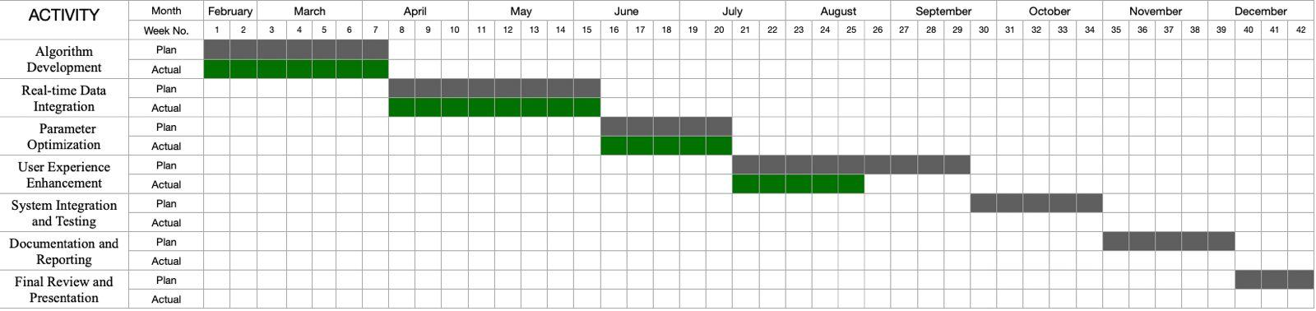

The work plan depicted in the Gantt chart outlines the timeline for different activities involved in a project, with planned (in green) and actual (in grey) timelines for each task.

Key Activities and Timelines:

1. Algorithm Development:
   * Planned: February to mid-March (Weeks 1-7).
   * Actual: Completed on schedule.
2. Real-Time Data Integration:
   * Planned: Mid-March to mid-May (Weeks 7-19).
   * Actual: Started as planned but extended slightly beyond the planned timeline.
3. Parameter Optimization:
   * Planned: May to mid-July (Weeks 19-28).
   * Actual: Started and completed as planned.
4. User Experience Enhancement:
   * Planned: July to mid-August (Weeks 28-33).
   * Actual: Started on time but extended slightly beyond the planned timeline.
5. System Integration and Testing:
   * Planned: Mid-August to September (Weeks 33-39).
   * Actual: Completed within the planned timeline.
6. Documentation and Reporting:
   * Planned: October (Weeks 39-42).
   * Actual: Yet to start.
7. Final Review and Presentation:
   * Planned: December (Weeks 47-50).
   * Actual: Yet to start.

**3.4 Tools and technology**

Emphasising the tools and technologies used to guarantee strong functionality, easy data integration, and a better user experience, this part describes the technological basis of the Stock Recommender System. The system generates accurate and quick stock recommendations by combining several APIs, machine learning frameworks, and development tools.  
  
API Integration main sources: Accessing real-time financial data, historical stock prices, and market indicators depends on the Yahoo Finance API, which is absolutely fundamental to the system. It offers thorough financial data necessary for examining market movements and stock performance.

Designed in tandem with Yahoo Finance, StockSymbol API provides more stock data and financial statistics not otherwise available from Yahoo Finance. It improves the capacity of the system to obtain comprehensive stock data including less common financial measures and instantaneous changes in stock symbols and corporate data.aaaaaaaaaaaaaaaaaaaaaaaaaaaaaaaaaaaaaaaaaaaaaaaaa

Strategy for API Utilisation: Periodically both APIs are consulted to refresh the database of the system with the most recent market data. This guarantees the basis of the stock recommendations—the most current data.

Data Harmonisation: To offer a single perspective of the stock market, data from both APIs is harmonic. To guarantee correctness and compatibility in analytics, particular focus is on data formatting and normalising.aaaaaaaaaaaaaaaaaaaaaaaaaaaaaaaaaaaaaaaaaaaaaaaaaaaaaaaaaaaaaaaa

Thanks to its strong compute capacity and simplicity of use, Google Colab remains the main platform used for creating and training machine learning models. Crucially for processing vast amounts of data and effectively training complicated models, it enables the use of high-performance GPUs and TPUs supplied by Google Cloud.

**DESIGN SPECIFICATIONS**



**4.1 System Architecture**

* **MVC Architecture**: In an MVC architecture, the application is divided into three interconnected components. Here's how they interact in a stock recommender system.

Model: This is the central component of the pattern. It is the application's dynamic data structure, independent of the user interface. It directly manages the data, logic, and rules of the application. For a stock recommender system, the Model would manage the user profiles, stock data, analysis results, etc.

View: Any representation of information, such as a chart, diagram, or table. Multiple views of the same information are possible. In the stock recommender system, the View would display the stocks, analysis results, and recommendations to the user. Controller: Accepts input and converts it to commands for the Model or View. In the context of a stock recommender system, the Controller would handle user inputs (like risk tolerance and investment preferences), pass them to the Model for processing, and update the View with new data.

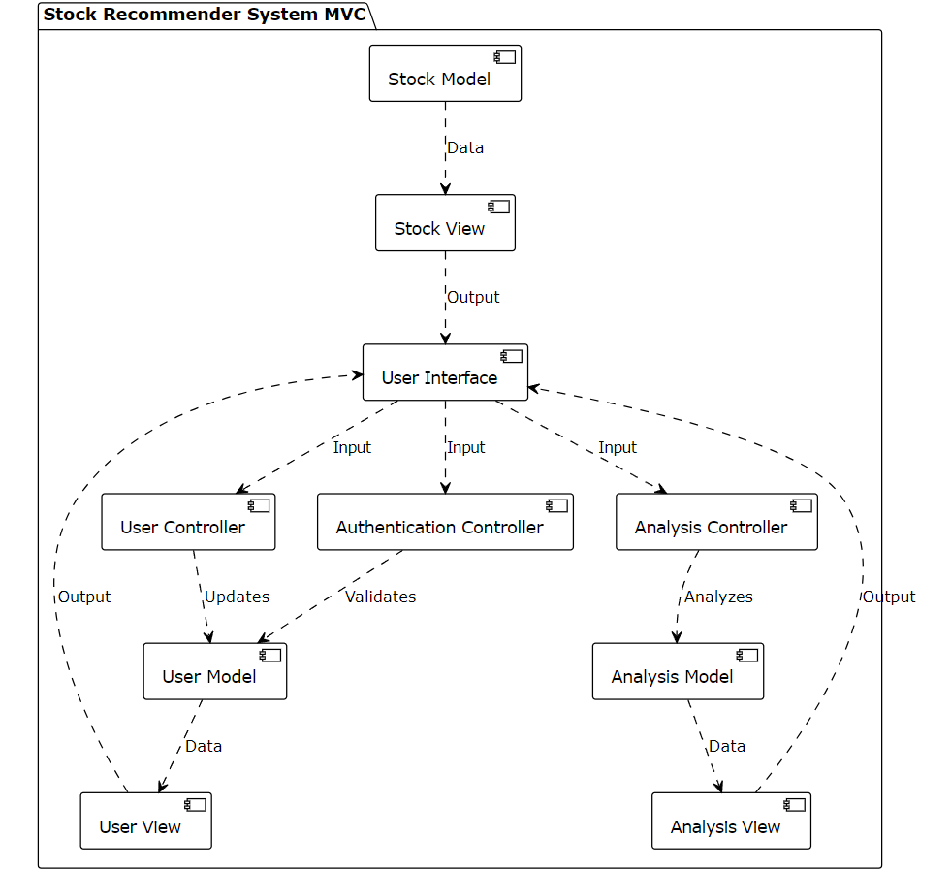

Figure No.-1

* **Tier Architecture**: In tier architecture, the application is structured into physically separate layers that handle specific types of processing. For a web-based stock recommender system, we typically consider a three-tier architecture, which includes:

Presentation Tier: The topmost level of the application is the user interface (UI). It communicates with the other tiers by outputing results to the browser/client tier and all other tiers in the network.

Logic Tier: Also known as the middle tier, business logic tier, or application tier, this layer coordinates the application, processes commands, makes logical decisions and evaluations, and performs calculations. It moves and processes data between the two surrounding layers.

Data Tier: This includes the data persistence mechanisms (database servers, file shares, etc.) and the data access layer that encapsulates the persistence mechanisms and exposes the data. The data tier keeps data neutral and independent from application servers or business logic.

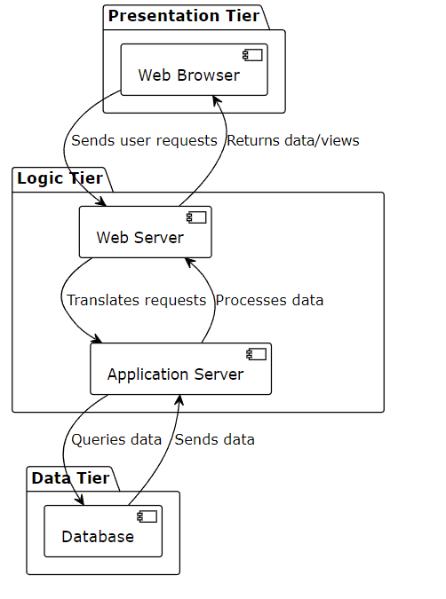

Figure No.-2

**4.2 Design level Diagrams**

* **Swimlane Diagram:** The sequence diagram you have submitted is a visual representation of the interactions between the User, the System, and the Admin in a stock recommendation system.  
    
  User Interactions:aaaaaaaaaaaaaa

aaaaaaaaaaaaaaaaaaaaaaaaaaaaaaaaaaaaaaaaaaaaaaaaaaaaaa  
Sign Up/Sign In: The user initiates the process by either creating an account or logging in to the system. The user's credentials are verified by the system upon sign-in.  
The user can input their investment objectives and risk factor after signing in, which are essential for personalising stock recommendations.

View Suggestions: The user is provided with stock recommendations that are tailored to their preferences and the system's analyses after the input has been completed.

Processes of the system:aaaaaaaaaaaaaaaaaaaaaaaaaaaaaaaaaaaaaaaaaaaaaaaaaaaaaaaaaaaaaa  
Credential Verification: The system determines whether the user's credentials are legitimate. The system retrieves data from APIs and libraries if the credentials are legitimate.

Run News Sentiment Analysis: The system analyses market sentiment in relation to equities by processing news data, which in turn affects the recommendations.

Error Message/Forgot Password/Create New Password: The system will display an error message and offer the option to recover the username or create a new password if the credentials are invalid.

Select Investment Sector: The system enables the user to select specific investment sectors, thereby further refining the recommendation process.

Conduct Technical and Fundamental Analysis: Utilising the data it has acquired, the system implements technical and fundamental analyses to assess equities.

Admin Interactions:aaaaaaaaaaaaaaaaaaaaaaaaaaaaaaaaaaaaaaaaaaaaaaaaaaaaaaaaaaaaaaaaaa  
administer Users: The administrator has the capacity to administer user accounts, which includes the addition, updating, and removal of users.

System Configuration: The administrator is also accountable for the system's configuration, which guarantees its efficient and seamless operation.

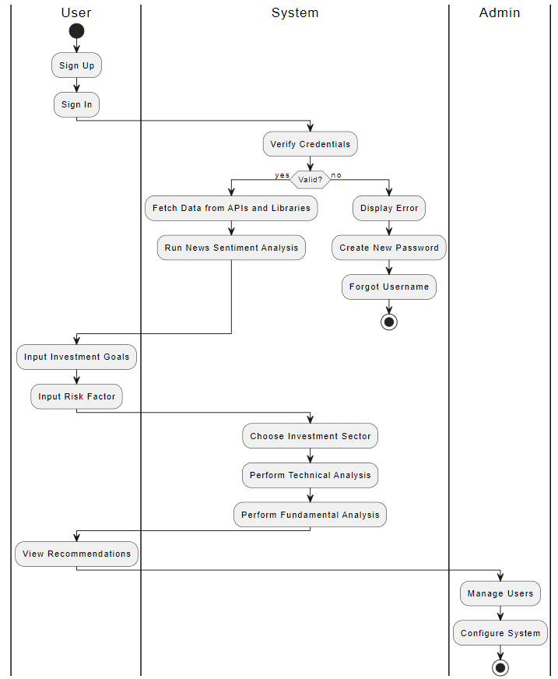

Figure No.-3

* **Activity Diagram:** User Process:

User Sign Up: The process begins with the user signing up for an account.

User Login: After signing up, the user logs into the system.

Credential Validation: The system checks if the user's login credentials are valid.

If Valid:

Manage Profile: The user can manage their profile settings.

Upload Image: The user can upload an image (or other data) to the system.

Provide Feedback: After the upload, the user can provide feedback on the process or results.

Download Result: The user can download the processed result, such as an analyzed or modified image.

View Upload History: The user can view their upload history, checking past activities or results.

If Not Valid:

Display Login Error: The system shows an error message, prompting the user to correct their login details.

Admin Process:

Model Management: The admin can manage the models used by the system, which might involve updating, training, or deploying models for tasks like image processing.

Create New Password: If needed, the admin can create a new password for themselves or other users.

Forgot Password: There’s an option for password recovery if the admin forgets their credentials.

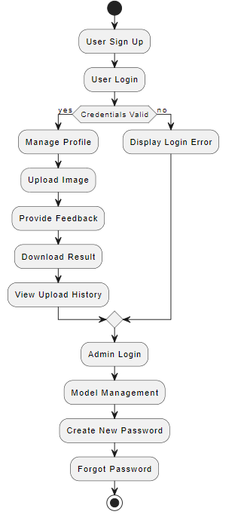

Figure No.-4

* 1. **User Interface Diagram**
* **ER Diagram**: An Entity-Relationship (ER) model for a system that encompasses users, assets, transactions, and analyses is illustrated in the diagram you uploaded.  
    
  Userid: This is the PK that identifies the fundamental entity of the system, the user. Users are assigned a PROFILE, which is linked to various risk factors and preferences. ProfileId is the identifier for the profile, and users may have multiple profiles. Furthermore, the logon entity is retained by users, which includes the IP address, date/time, and logon instance. By virtue of loginId, the user is associated with the login entity.aaaaaaaaaaaaaaaaaaaaaaaaaaaaa  
    
  STOCK Entity: The stockId includes the name and price of each stock, as well as a unique identifier. A user's financial transactions, which encompass the acquisition or disposition of securities, are documented by the TRANSACTION entity. Every transaction is identified by a unique transactionId and is associated with a specific userid and stockId. The amount and nature of transaction (buy or sell) are recorded.aaaaaaaaaaaaaaaaaaaaaaaaaaaaaaaaaaaaaaaaa  
    
  ANALYSIS Entity: The analysisId is a unique identifier that is assigned to each analysis that is associated with a stock. This identity is used to generate a report on the stock's performance or potential. By virtue of its stockId, each analysis is linked to a specific stock and is contingent upon its performance. In this ER model, a thorough examination of the system's management of stock transactions, user interactions, and analyses is provided.

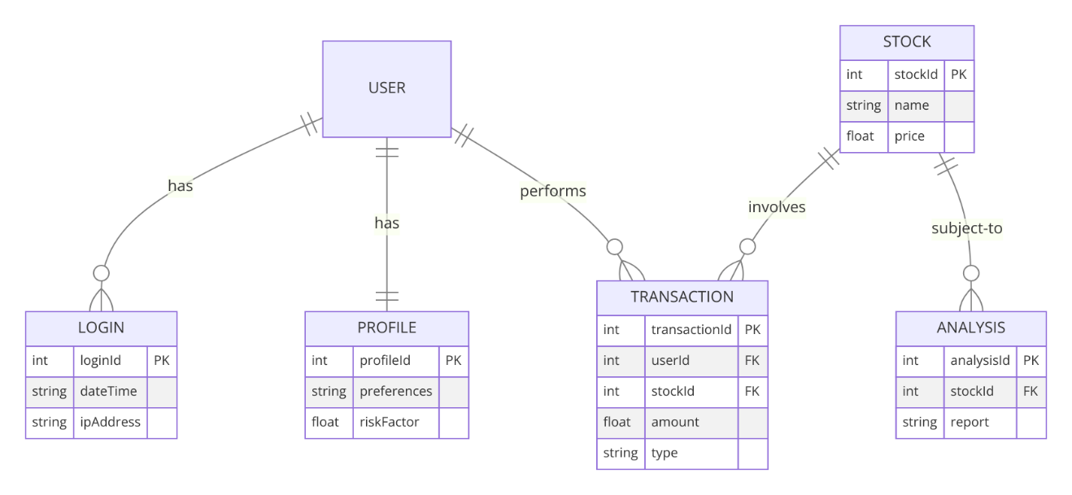

Figure No.-5

* **Data Flow Diagrams**: The Level 0 DFD (Context Diagram) is the most comprehensive view of the system, illustrating the overall process without delving into specifics. This section delineates the manner in which users interface with the system. Begin by logging in, and the system verifies the user's credentials. Upon authentication, the user's profile is retrieved, and the user is able to establish investment objectives and risk tolerances. Following sentiment analysis, the system retrieves data from APIs, conducts technical and fundamental analysis, and ultimately recommends equities based on the analysis. The system redirects the user to the sign-up page if authentication fails.aaaaaaaaaaaaaaaaaaaaaa\

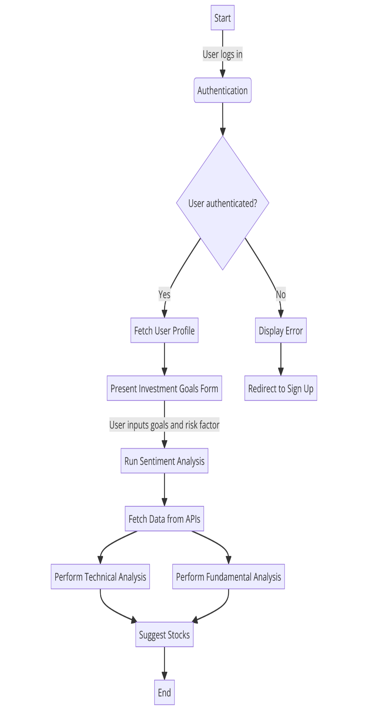  
  
Figure No.-6

**DFD Level** **1**: This level deconstructs the high-level processes into more comprehensive subprocesses. the Authentication Service verifies the credentials provided by the user after they have accessed the system. The user profile is retrieved from the database by the Profile Service if it is successful, enabling the user to view and modify their preferences. The Sentiment Analysis Service processes news data, while the Technical Service and Fundamental Service conduct the corresponding analyses on data obtained from external APIs. The user is then presented with stock recommendations by the Recommendation Engine, which compiles these analyses.aaaaaaaaaaaaaaaaaaaaaaaaaaaaaaaaaaaaaaaaaaaaaaa

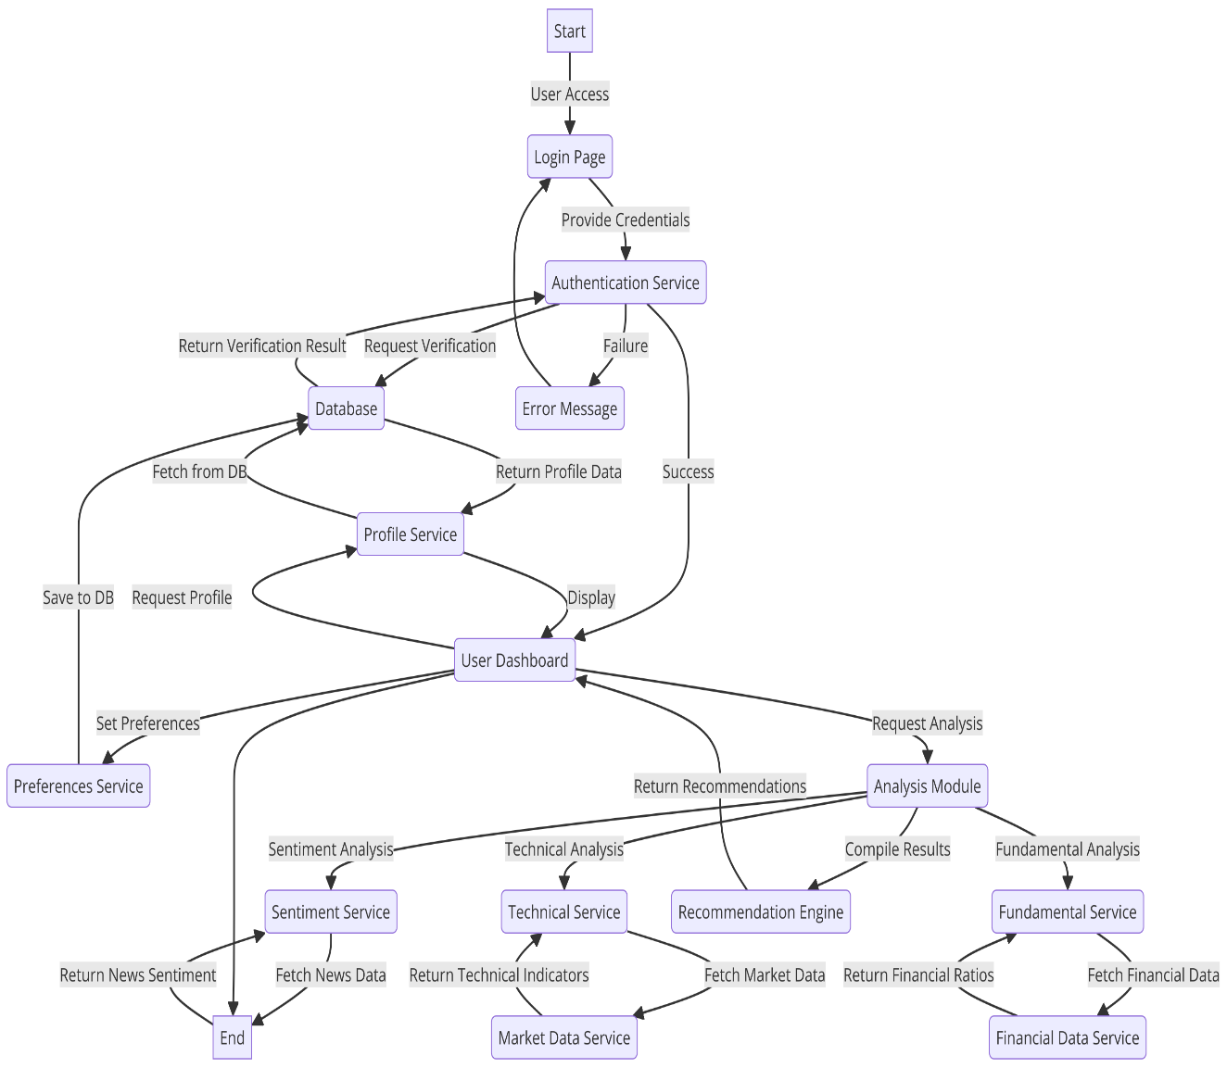

Figure No.-7

**DFD Level 2**: This level further decomposes particular processes into their detailed components:  
  
User authentication: The procedure commences with the user entering their credentials on the login page. Interacting with the database, the Authentication Service validates these credentials. Access to the dashboard is granted to the user if their profile is valid, allowing them to view and amend it through the Profile Service. Errors are indicated when they are not legitimate.aaaaaaaaaaaaaaaaaaaaaaaaaaaaaaaaaaaaaaaaaaaaaaaaaaaaaaaaaaaaaaaaaaaaaa  
  
Management of Profiles: This procedure delineates the manner in which the profile service interacts with the database to retrieve and store user preferences. Users have the ability to establish their preferences, which are subsequently stored in the database and displayed in their profiles.aaaaaaaaaaaaaaaaaaaaaaaaaaaaaaaaaaaaaaaaaaaaaaaaaaaaaaaaaaaaaaaaaaaaaaa  
  
Analyst Module: This procedure entails the sentiment, technical, and foundational analysis services, each of which retrieves data from external APIs. In order to generate stock suggestions for the user, the analysis module compiles the results and then transmits them to the Recommendation Service.aaaaaaaaaaaaaaaaaaaaaaaaaaaaaaaaaaaaaaaaaaaaaaaaaaaaaaaa  
  
The collection of these diagrams offers a comprehensive perspective on the data flow of the system, encompassing the analysis and recommendation processes, as well as user authentication and profile administration.

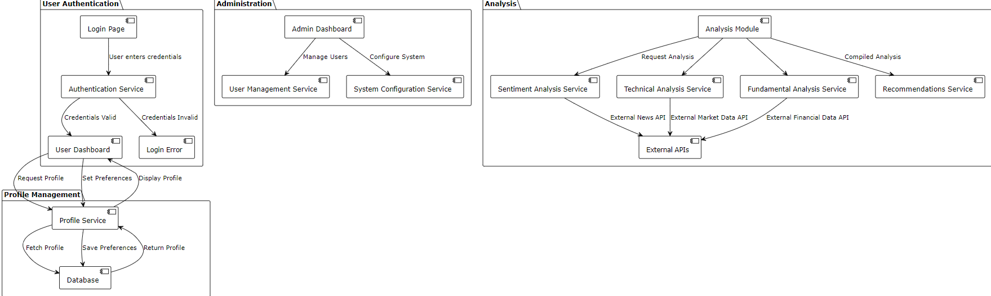

Figure No.-8

* **Use case**: The use case diagram you provided outlines the key functionalities of a Stock Recommender System and the interactions between the system and various actors, including the user, sentiment analysis engine, data providers, analysis tools, and the system itself.

**Actors:**

User: The primary actor who interacts with the system to manage their investment profile and receive stock recommendations.

SentimentAnalysis Engine: A system component that provides sentiment analysis of news related to stocks.

Data Providers: External sources that supply financial and market data.

Analysis Tools: Components that perform various analyses (technical, fundamental).

System: Represents the internal components handling authentication and other system-level processes.

**Key Use Cases:**

Sign In/Sign Up: The user starts by signing into the system. If they do not have an account, they can sign up. The system verifies credentials during sign-in, and any errors prompt the user to edit their credentials.

Input Risk Factor and Investment Goals: After signing in, the user can input their risk factor and investment goals. These inputs are crucial for tailoring stock recommendations.

Choose Investment Sector: The user can choose specific sectors they are interested in, which will influence the recommendations provided.

Run News Sentiment Analysis: The system includes a feature that runs sentiment analysis on news articles to gauge market sentiment towards certain stocks.

Fetch Data from APIs and Libraries: The system fetches real-time data from external APIs and libraries, which is essential for performing up-to-date analyses.

Perform Fundamental and Technical Analysis: These are core functionalities where the system analyzes stocks using fundamental metrics (like financial ratios) and technical indicators (like moving averages).

Suggest Stocks: Based on the analyses and user preferences, the system suggests stocks that align with the user's goals and risk tolerance.

**Extensions:**

Login Error: This handles scenarios where the user encounters issues during login.

Edit Credentials: If login errors occur, the user has the option to edit their credentials.

Verify Credentials: This is an extended process of the sign-in, ensuring the security and accuracy of user authentication.

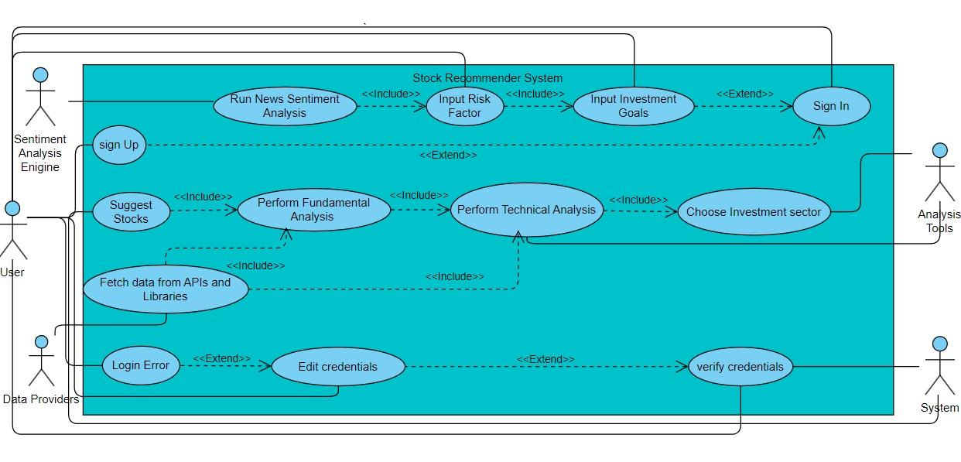

Figure No.-9

* 1. **Snapshots of Working prototype**

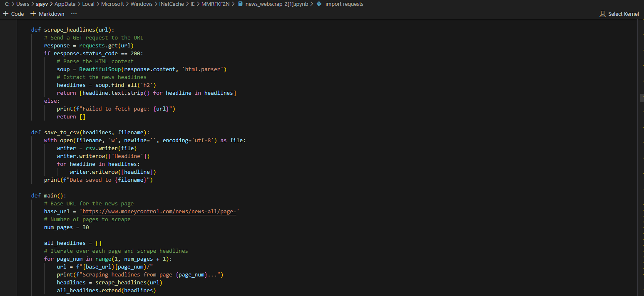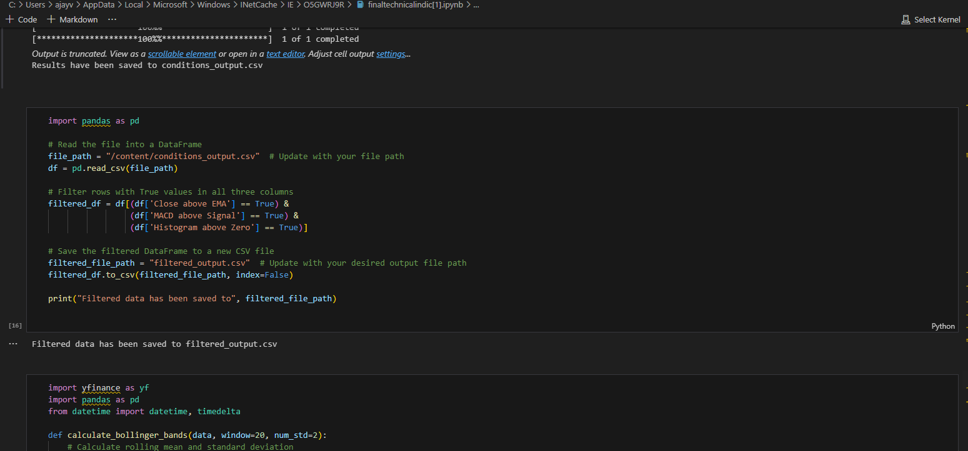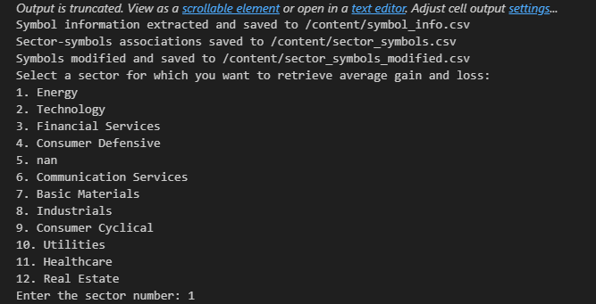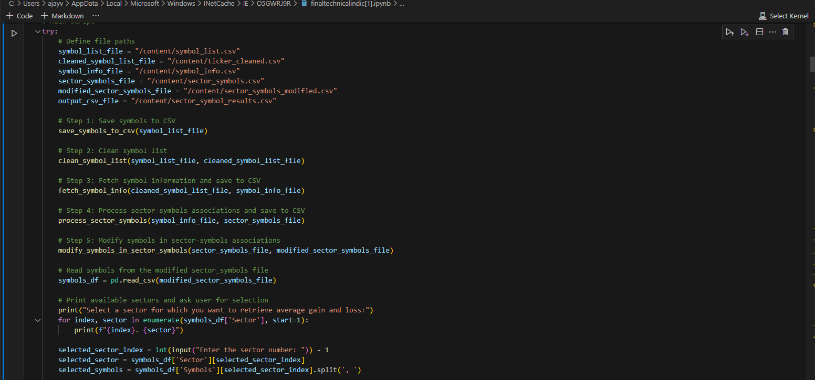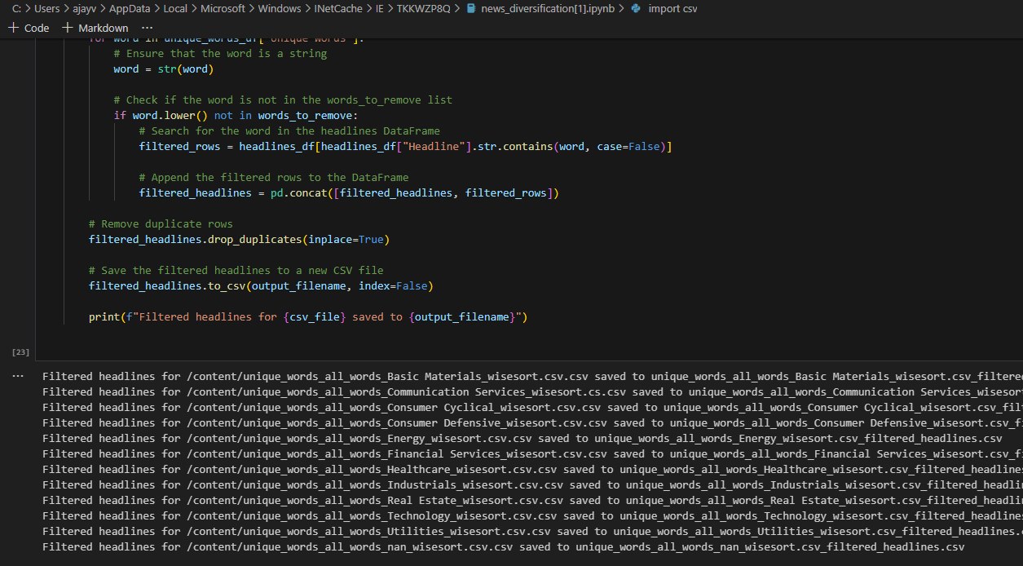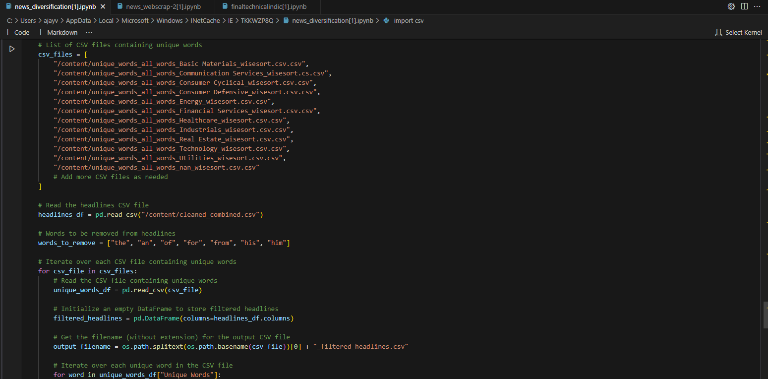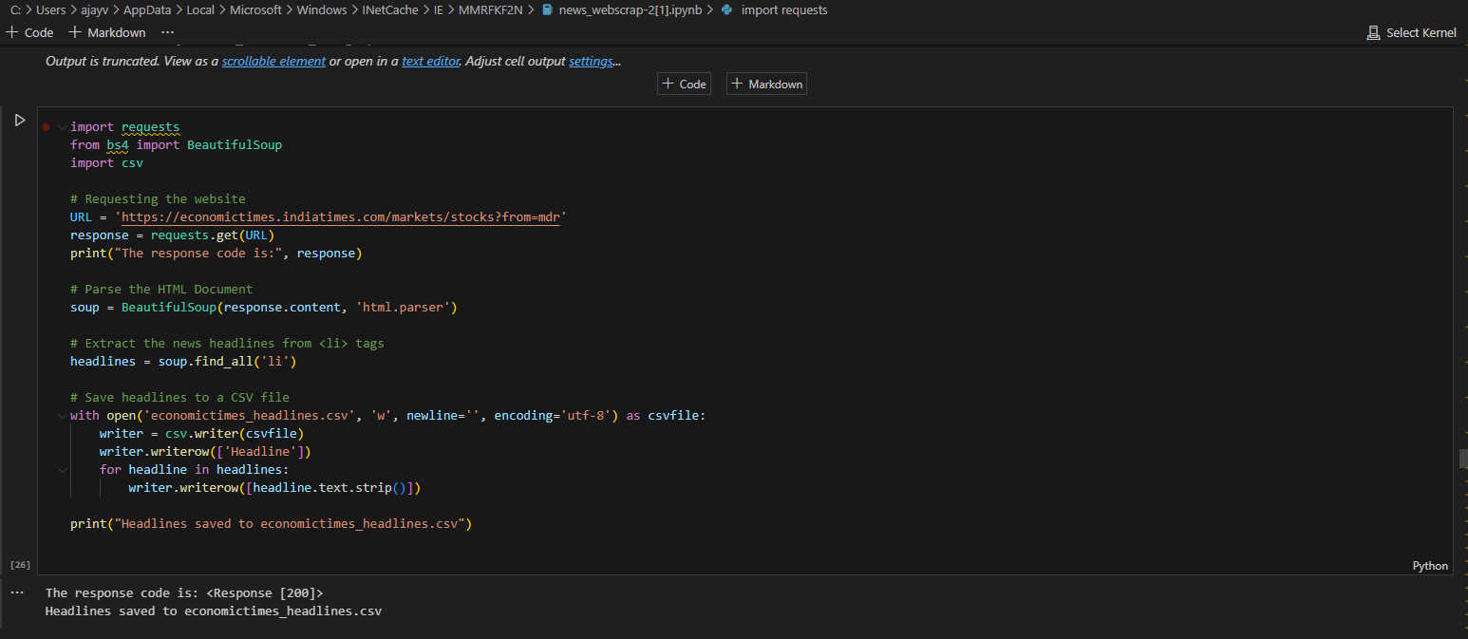

**CONCLUSION AND FUTURE SCOPE**



**5.1 Work Accomplished:** Work Completed to Date:

Algorithm Development (February - March, Weeks 1-7):aaaaaaaaaaaaaaaaaaaaaaaaaaaaaaaaaaa  
Objective: Create and enhance algorithms for stock classification that are tailored to the specific needs of the industry.aaaaaaaaaaaaaaaaaaaaaaaaaaaaaaaaaaaaaaaaaaaaaaaaaaaaaaaaaaaaaaaaaaa  
Status: Completed in accordance with the established timeline. The system has effectively developed algorithms for stock sorting, which enable it to offer targeted recommendations based on industry-specific criteria.aaaaaaaaaaaaaaaaaaaaaaaaaaaaaaaaaaaaaaaaaaaaaaaaaaaaaaaaaaaaa  
  
  
Real-time Data Integration (March - May, Weeks 7-19):aaaaaaaaaaaaaaaaaaaaaaaaaaaaaaaaaaaa  
Objective: Develop a dependable system for the daily update of data from a variety of sources, including the stock symbol API and Yahoo Finance.  
Status: Nearly finished, with only minor setbacks. The real-time data integration system has been established and is operational, guaranteeing that stock lists are consistently updated on a daily basis.

Parameter Optimisation (Weeks 19-28, May - July):aaaaaaaaaaaaaaaaaaaaaaaaaaaaaaaaaaaaaaaa  
Objective: Enhance the evaluation of stocks by optimising the utilisation of financial ratios and indicators, as well as incorporating machine learning models and candlestick charts.  
Status: Presently in progress. Although substantial progress has been achieved in the optimisation of financial ratios and indicators, the integration of machine learning models and candlestick charts is still in progress. This work is essential for enhancing the predictive capabilities and analytical profundity of the stock recommendation system.  
  
  
Presently, the phase is as followsaaaaaaaaaaaaaaaaaaaaaaaaaaaaaaaaaaaaaaaaaaaaaaaaaaaaaaaa  
User Experience Improvement (Weeks 28-33) (July - August):aaaaaaaaaaaaaaaaaaaaaaaaaaaaaa  
The current emphasis is on enhancing the user interface to guarantee that it is user-friendly and accessible to a wide range of users, including novice investors and seasoned investors.

**5.2 Conclusions**

The stock recommendation system project is a complete initiative aimed at creating a complex platform that utilises advanced algorithms, real-time data integration, machine learning models, and intuitive user interface design. The objective of the project was to develop a platform that can offer precise stock recommendations by considering industry-specific criteria, delivering daily market updates, and utilising dynamic financial data.aaaaaaaaaaaaaaaaaaaaaaaaaaaaaaaaaa  
  
Notable Accomplishments:aaaaaaaaaaaaaaaaaaaaaaaaaaaaaaaaaaaaaaaaaaaaaaaaaaaaaaaaaaaaaa  
  
Algorithm Development: Created effective algorithms for sorting stocks according to industry-specific criteria, guaranteeing that the recommendations align with the user's preferences.  
Implemented a resilient system to integrate real-time stock data from many sources, guaranteeing that the platform's recommendations are consistently updated and accurately represent the prevailing market conditions.aaaaaaaaaaaaaaaaaaaaaaaaaaaaaaaaaaaaaaaaaaaaaaaa  
Optimising parameters: Significant progress has been made in optimising the selection of financial ratios and indicators. Integrating machine learning models with candlestick chart analysis is anticipated to improve the predicted accuracy and comprehensiveness of the system's stock ratings.aaaaaaaaaaaaaaaaaaaaaaaaaaaaaaaaaaaaaaaaaaaaaaaaaaaaaaaaaaaaaaaaaaaaaaaaaaa  
Improving User Experience: Current efforts are being made to enhance the user interface, aiming to make the platform accessible and entertaining for both experienced investors and novices.  
Challenges and Learning: Although the project mostly followed the plan, little setbacks in integrating real-time data and continuously optimising parameters revealed the intricacy of developing a smooth, real-time stock recommendation system. The iterative methodology in development, namely in enhancing machine learning models and incorporating them with conventional financial analysis tools, has played a crucial role in tackling these difficulties.

Prospective Endeavours:aaaaaaaaaaaaaaaaaaaaaaaaaaaaaaaaaaaaaaaaaaaaaaaaaaaaaaaaaaaaaaaa  
In the future, the project will prioritise the completion of integrating machine learning models and candlestick charts, as well as finalising the changes to the user experience. The last stage will entail comprehensive system integration, testing, and documentation, culminating in a final evaluation and presentation.aaaaaaaaaaaaaaaaaaaaaaaaaaaaaaaaaaaaaaaaaaaaaaaaaaaaaaaaaaaaa  
  
Ultimately, the project has established a solid groundwork for an influential stock recommendation system that combines advanced technology with a user-friendly interface, making it a valuable resource for investors at any level of expertise.

**5.3 Environmental/Social Benefits**

The system facilitates more informed and expeditious investment decisions by utilising real-time data and advanced algorithms. This has the potential to result in improved financial outcomes for individual investors, which can contribute to the economic stability and development of the personal and broader market.aaaaaaaaaaaaaaaaaaaaaaaaaaaaaaaaaaaaaaaaaaaaaaaaaaaaaaaaaaaaa  
  
Cost-Effective Financial Services: The system democratises access to sophisticated financial analysis tools, which were previously exclusively available to institutional investors or at a significantly higher cost. The provision of these services to a broader audience promotes economic inclusivity, allowing a greater number of individuals to engage in the stock market and potentially enhance their financial well-being.aaaaaaaaaaaaaaaaaaaaaaaaaaaaaaaaaaaaaaaaaa  
  
The system improves market efficiency by rapidly processing and analysing extensive quantities of market data. The optimal allocation of resources is facilitated by efficient markets, which are essential for economic development. This enables businesses to more easily secure capital and investors to more reliably identify profitable opportunities.

**5.4 Future Work Plan**

Going forward, the project will prioritise the completion of the **Parameter Optimisation** phase by August-September. This entails completing the integration and fine-tuning of machine learning models and candlestick chart analysis to improve the accuracy of stock appraisal. A thorough process of backtesting will be carried out to confirm the dependability and effectiveness of these optimised parameters.aaaaaaaaaaaaaaaaaaaaaaaaaaaaaaaaaaaaaaaaaaaaaaa   
  
Concurrently, there will be ongoing work to enhance the user experience from September to October. This entails performing user testing to collect input, incorporating essential interface enhancements to enhance usability and accessibility, and guaranteeing that the platform is adaptable to several devices, including mobile and desktop.

After implementing these improvements, the project will go to the phase of System Integration and Testing from October to November. In this phase, the process entails combining all elements, including the user interface, algorithms, data sources, and models, into a cohesive platform. A thorough examination, encompassing unit, integration, system, and load testing, will be conducted to detect and address any problems, thereby guaranteeing the system's functionality, dependability, and efficiency.aaaaaaaaaaaaaaaaaaaaaaaaaaaaaaaaaaaaaaaaaaaaaaa   
  
In November, attention will be directed towards Documentation and Reporting. Comprehensive technical documentation will be created, including a detailed description of the system's architecture, data flows, and algorithm logic. Furthermore, user manuals and support documentation will be created to aid end-users, and a comprehensive project report will be compiled to outline the development process, difficulties faced, and remedies employed.   
  
Ultimately, in December, the project will reach its pinnacle with a Final Review and Presentation. An all-encompassing presentation will be created to showcase the system's potential to stakeholders, emphasising important characteristics and advantages. This talk will also explore potential future improvements, such as broadening data sources and integrating more sophisticated analytical tools, to ensure the project's successful completion and establish a foundation for future advancements.

**REFERENCES**



1. Bodas-Sagi, D. (David), Conrad J. (Jonathan), Koutmos D. (Dimitrios). “Big data analytics in finance and accounting.” Journal of Accounting Literature, 41, 23-49, 2023.
2. Venkataraman V. (Venkat), ElBassiouny A. (Ahmed), Madhavan R. (Raja), Boughorbel S. (Sabri). “Limit order books and liquidity with machine learning methods.” Quarterly Journal of Finance, 9(2), 1950013, 2020.
3. Kim S.Y. (Sung Y.), Han S.S. (Sang Suk). “Machine learning models and bankruptcy prediction.” Journal of Management Analytics, 6(4), 331-352, 2022.
4. Chen Y. (Yan), Hao Y. (Ying), Wang Y. (Yi), Mahadevan S. (Sankaran). “A flexible modal KNN method and financial application.” Journal of Industrial and Management Optimization, 13(1), 299-312, 2017.
5. Althelaya K.A. (Khalid A.), El-Alfy E.M. (El-Sayed M.), Mohammed S. (Shankar). “Evaluation of bidirectional LSTM for short-and long-term stock market prediction.” 2018 9th International Conference on Information and Communication Systems (ICICS), IEEE, 2018.
6. Sezer O.B. (Obada B.), Ozbayoglu A.M. (A. Murat), Dogdu E. (Erdal). “A deep learning model for stock market forecasting via novel feature extraction and integration.” Journal of Business Economics and Management, 21(1), 224-241, 2020.
7. Liu L. (Lei), Wu J. (Jie), Liang L. (Lu), Zhu Q. (Qiao). “Accounting information quality and stock price crash risk: Evidence from China.” Journal of Business Finance & Accounting, 47(3-4), 513–530, 2020.
8. Rundo F. (Francesco), Trenta F. (Francesco), Di Stallo A.L. (Anna Lisa), Battiato S. (Sebastiano), Farinella G.M. (Giovanni). “Advanced machine learning to support digital marketing and sales.” Data Science and Pattern Recognition, 4(1), 1-18, 2019.
9. Sun J. (Jun), Xiao J. (Jing), He X. (Xiaohong), Wang C. (Chunfang). “Financial ratio selection for business failure prediction using soft set theory.” Journal of Industrial and Management Optimization, 15(2), 557-572, 2019.
10. Si J. (Jianfeng), Mukherjee A. (Arjun), Liu B. (Bing), Li Q. (Qing), Li H. (Huamin), Deng X. (Xiaowei). “Exploiting topic based twitter sentiment for stock prediction.” Proceedings of the 51st Annual Meeting of the Association for Computational Linguistics (Volume 2: Short Papers), Association for Computational Linguistics, 2013.
11. Ahari S.A. (Seyyed Abolghasem), Ardalan A. (Alireza), Aveh F.N. (Fatemeh Norouzi), Hamzeh A. (Alireza). “A hybrid deep learning model for stock market prediction using technical indicators and financial news articles.” Financial Innovation, 6(1), 1-21, 2020.